厦门迪太进出口有限公司
XIAMEN DITAI IMP.& EXP. CO.,LTD
地址：中国厦门禾祥西路鸿升大厦8A
8FL, Hongsheng Building, West Hexiang Road, Xiamen, Fujian, China
TEL:0592-26808108 Phone:+8615160094689 FAX:0592-2680880 E-mail: irene.zhang@xmditai.com
----------------------------------------------------------------------------------------------------------------------
DTPA Chelator CAS 67-43-6
DTPA Chelator CAS 67-43-6 Product Description
DTPA 99%
CAS:67-43-6
Diethylenetriaminepentaacetic Acid
used as chelating agent and complexing agent
in textile industry

Storage of DTPA Chelator CAS 67-43-6 :

DTPA Chelator CAS 67-43-6 should be stored in a cool, dry place, e.g.: a tightly closed container.
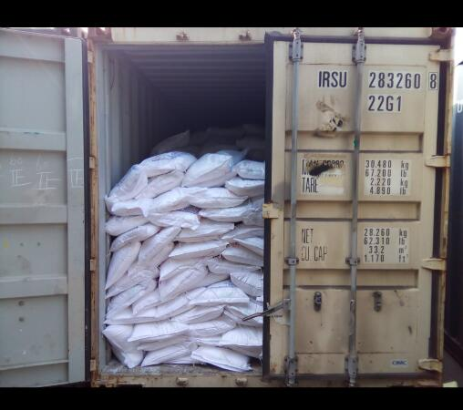
Specifications of DTPA Chelator CAS 67-43-6

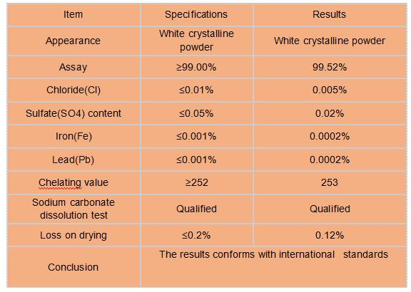
Packaging & Shipping of DTPA Chelator CAS 67-43-6
Packaging: 25kg bag
Delivery Detail: 15days after order confirmation

DTPA Chelator CAS 67-43-6 Storage
DTPA should be Stored in a dry and ventilated warehouse, avoid direct sunlight, lightly pile and put down.

